**Estimation Of Business Expanses**

Introduction:

Estimating business expenses is a critical aspect of financial planning and management for any organization. It involves predicting the costs associated with various operational activities, investments, and day-to-day functions. Accurate expense estimation is essential for budgeting, profit forecasting, and overall financial sustainability. In this discussion, we will explore the methods, factors, and strategies involved in the estimation of business expenses, providing valuable insights into this fundamental aspect of financial decision-making.

Purpose:

Expense estimation helps in creating comprehensive budgets, allowing businesses to allocate resources effectively and plan for future financial needs.

It enables long-term financial planning, aiding in setting financial goals, forecasting revenues, and ensuring that adequate funds are available to cover expenses.

Estimating expenses helps identify cost centers, facilitating efforts to control and reduce unnecessary expenditures, ultimately improving profitability.

Empathy Map:

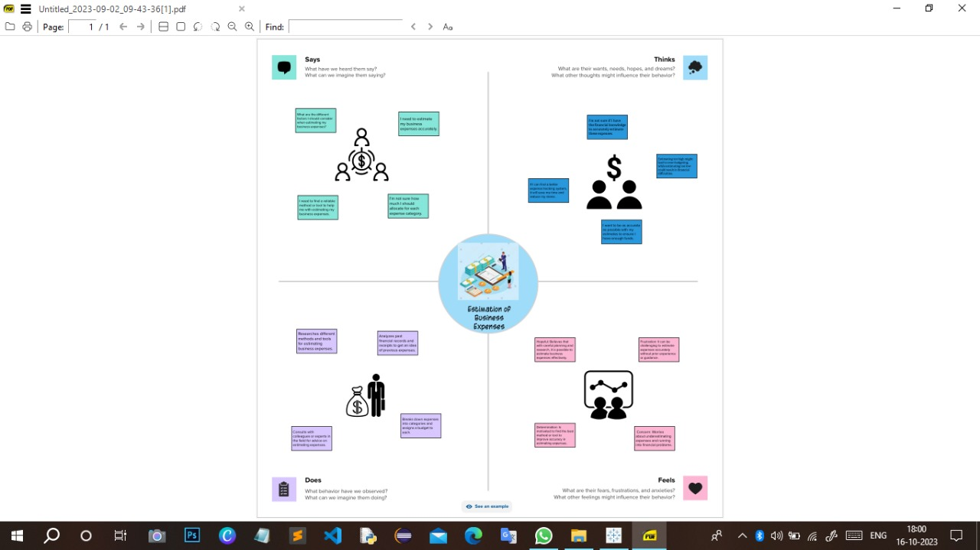

Brainstorming Map:

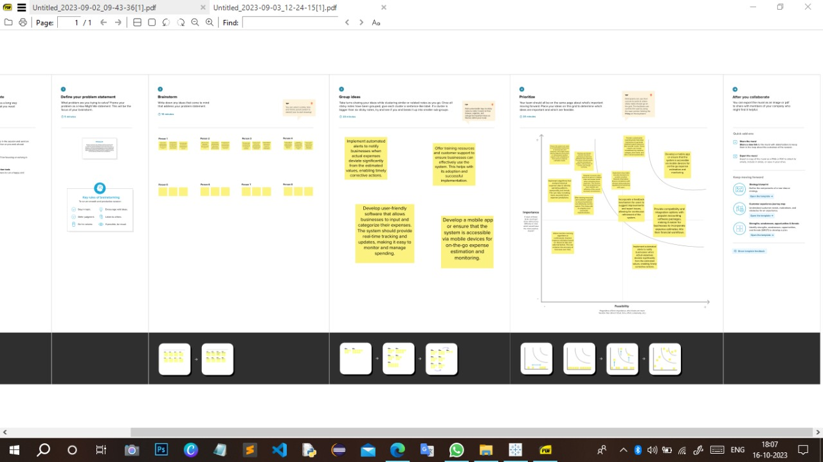

Result:

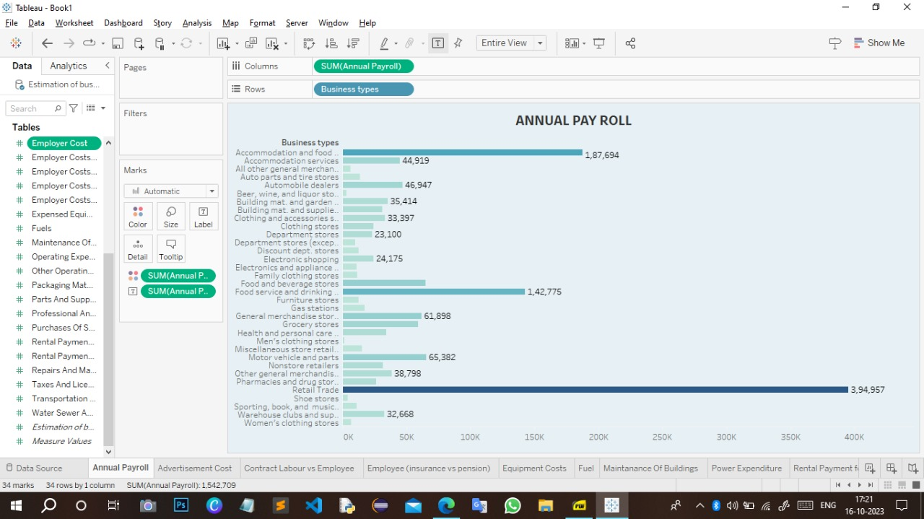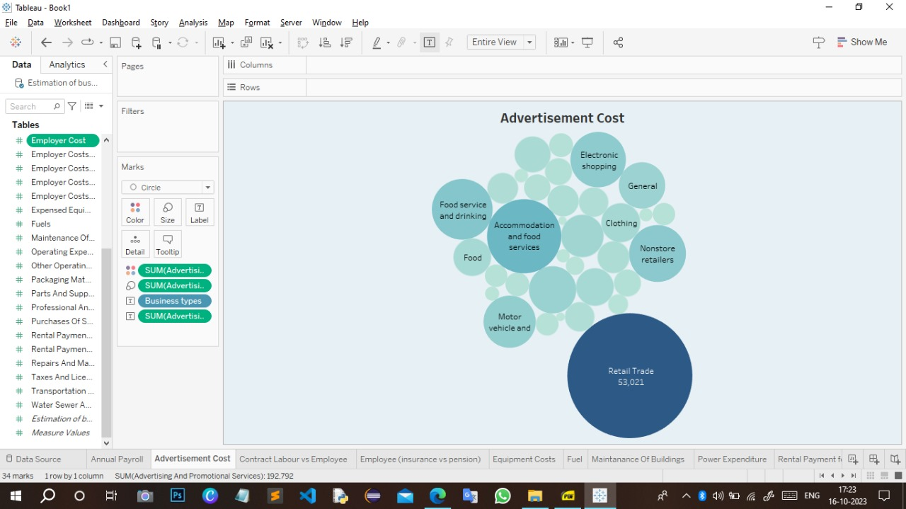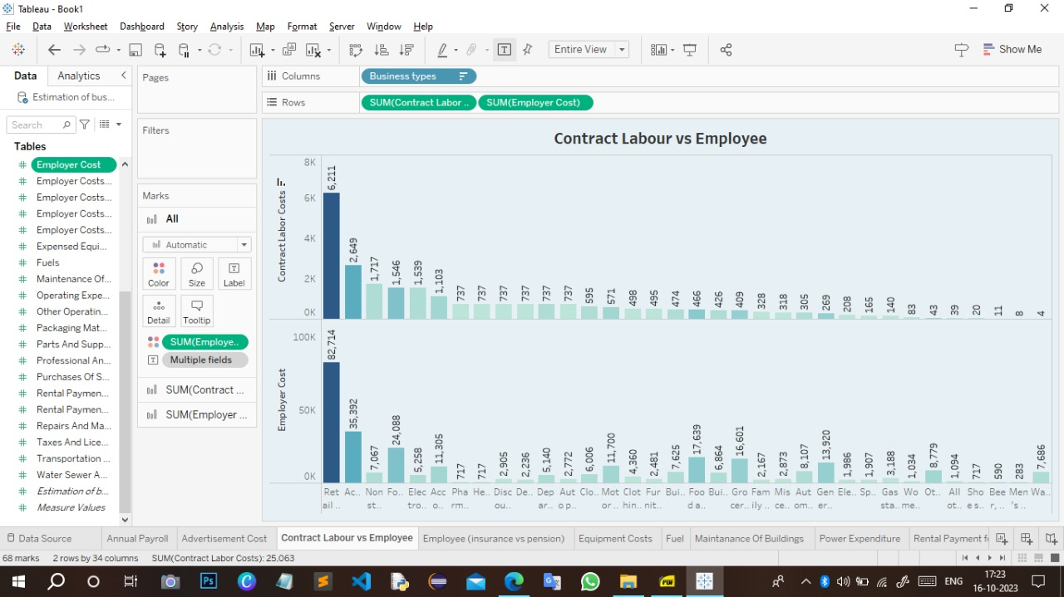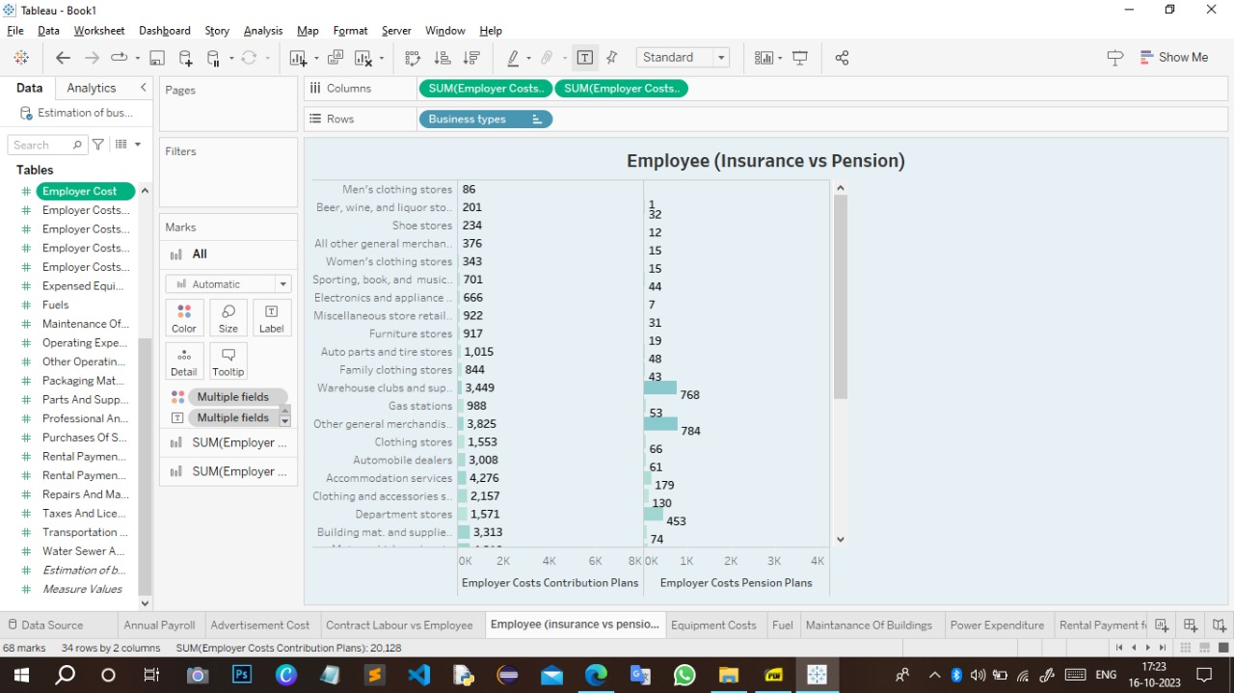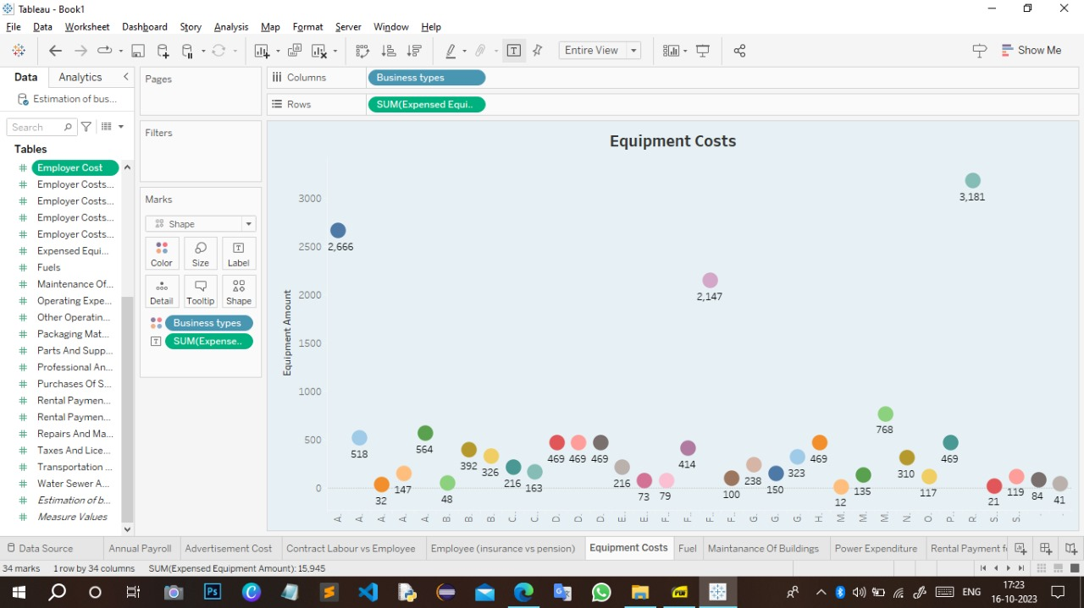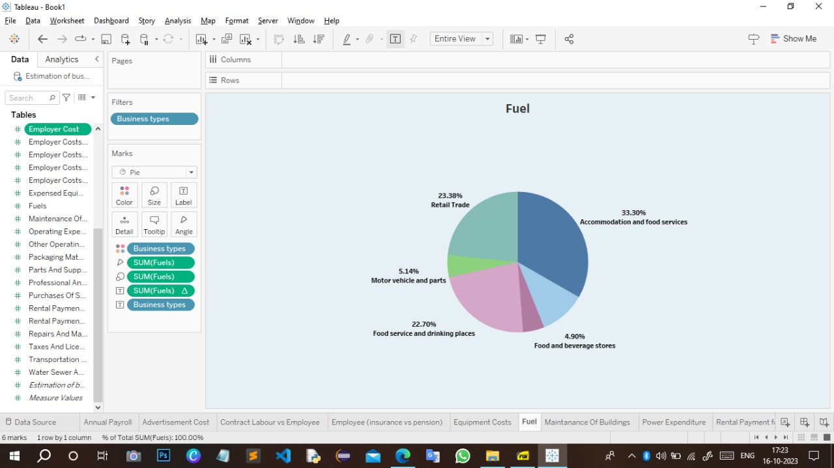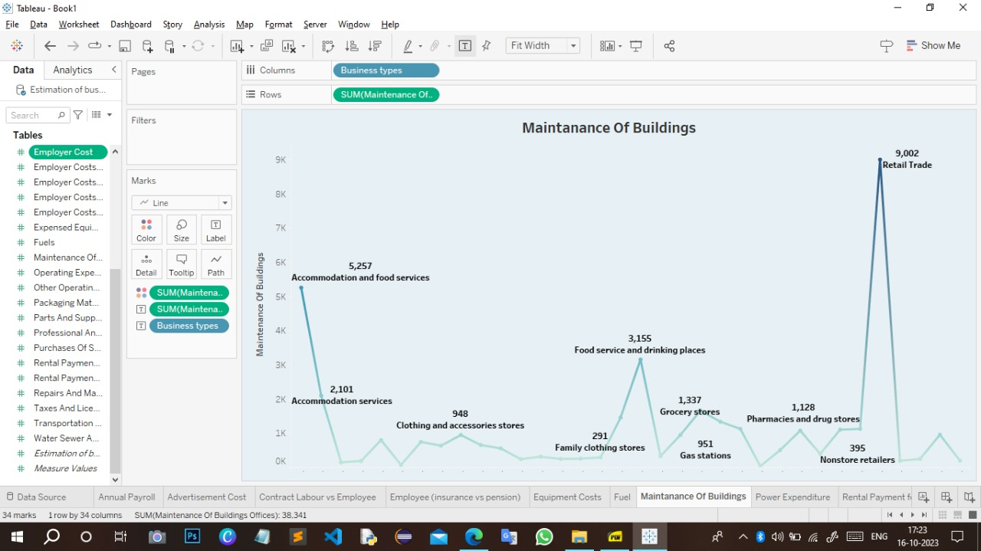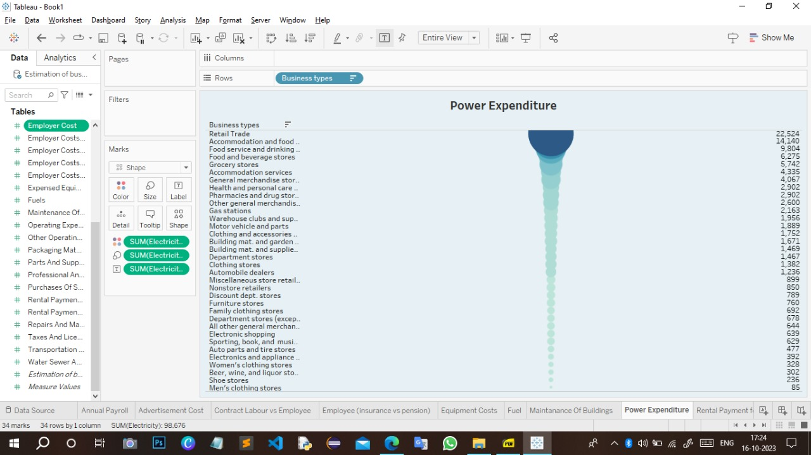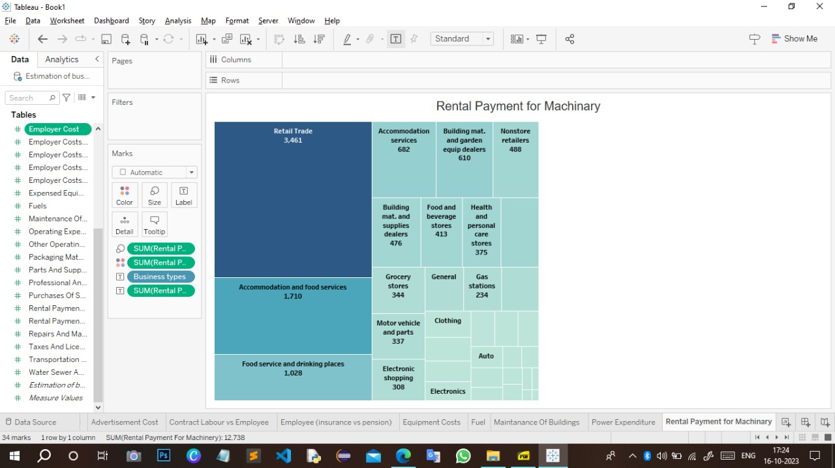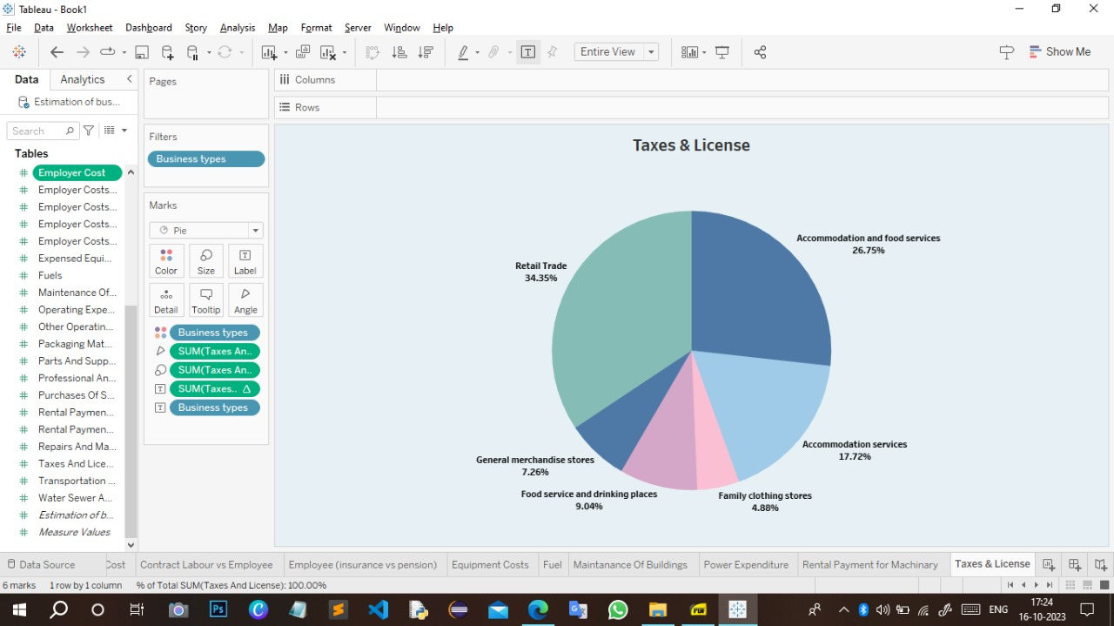

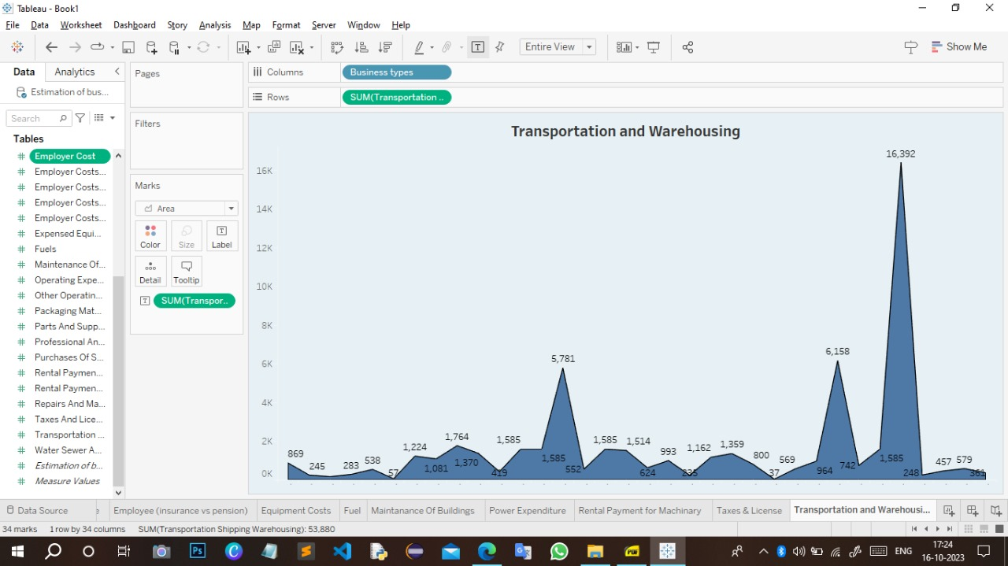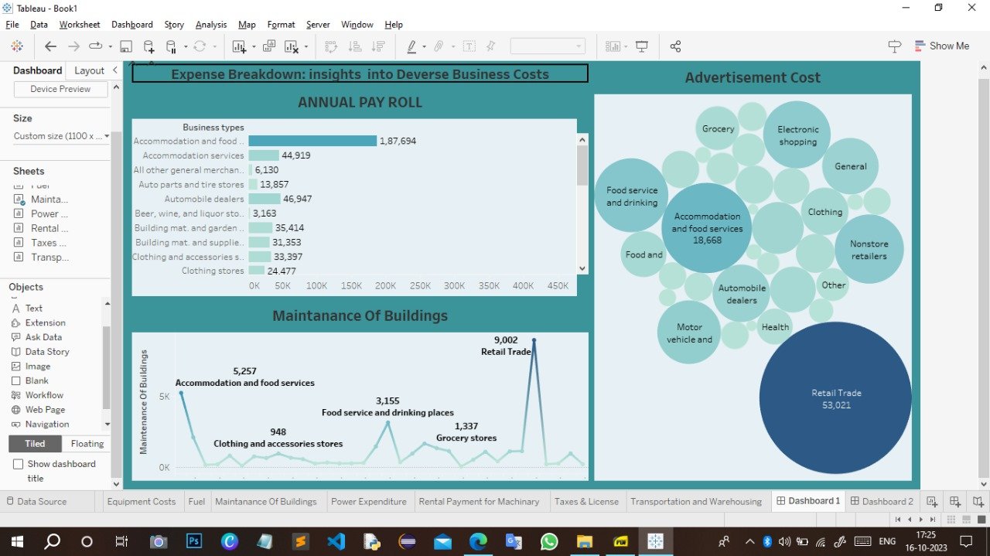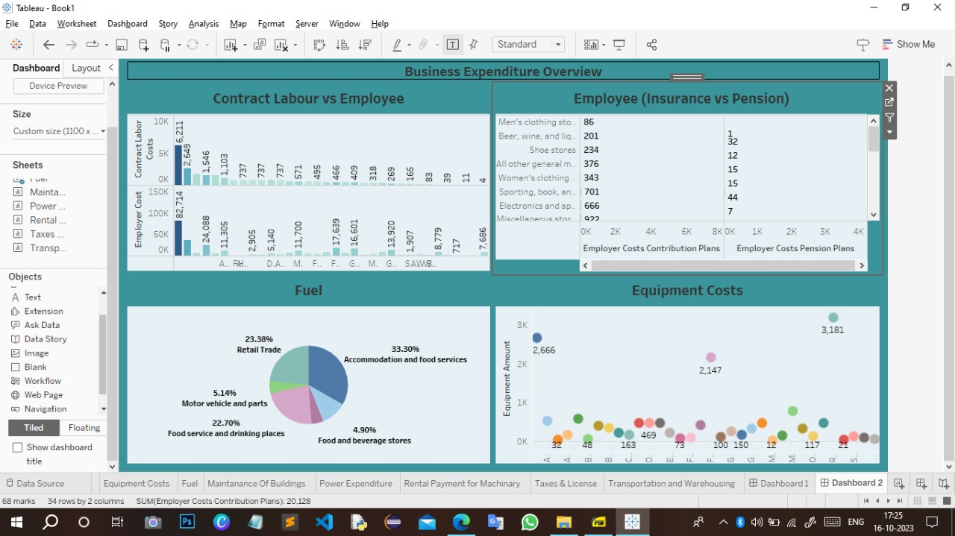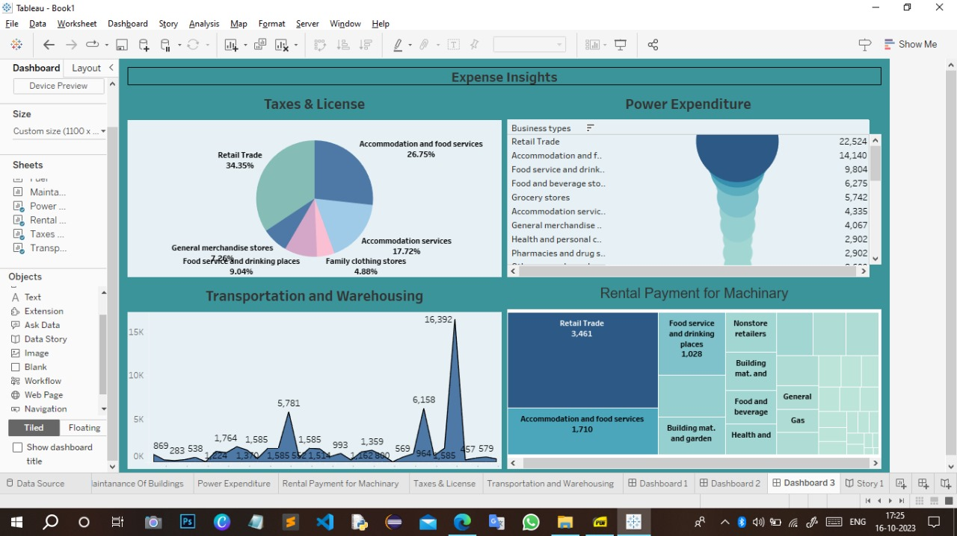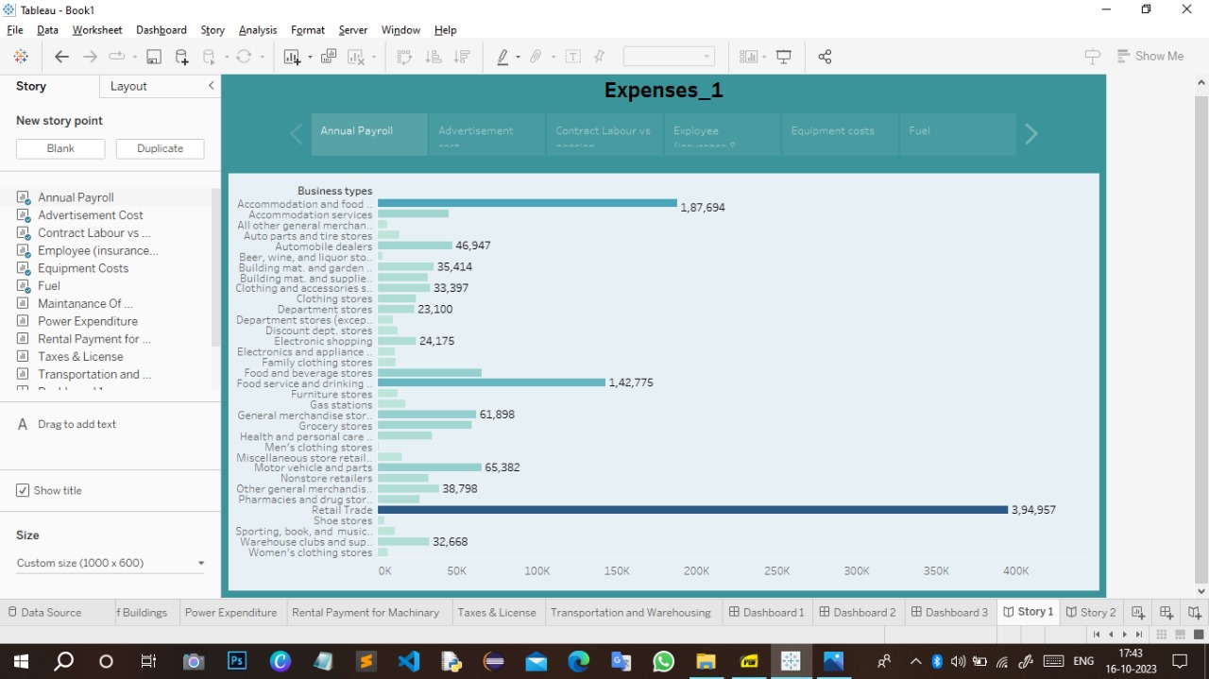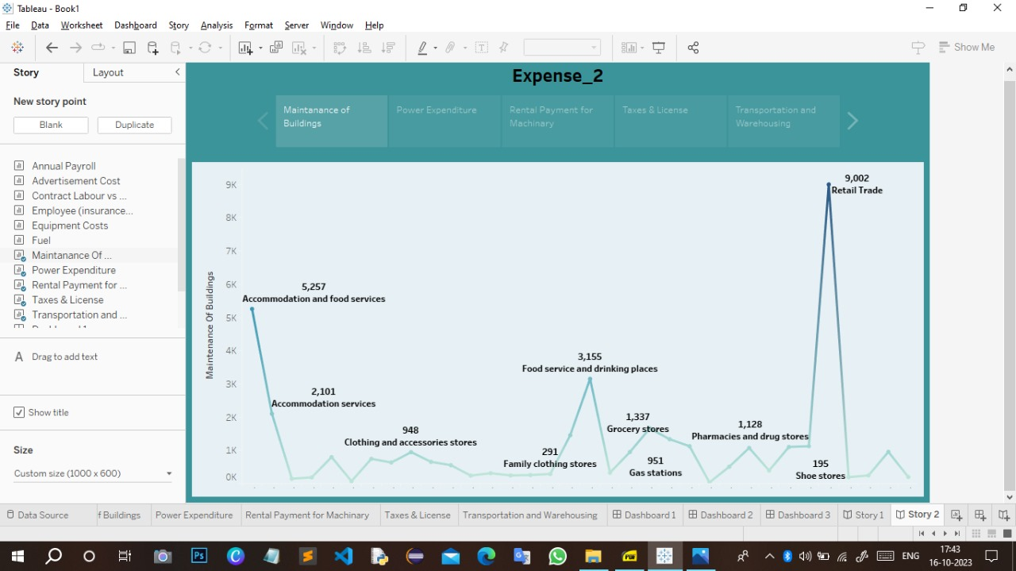

**Advantages**:

It allows for effective financial planning, helping businesses allocate resources wisely and set realistic financial goals.

Expense estimation is essential for creating budgets, ensuring that a company can operate within its means and meet its financial obligations.

Businesses can allocate resources efficiently to different departments or projects based on estimated expenses, optimizing overall performance.

Estimating expenses helps identify cost-saving opportunities and control unnecessary expenditures, thereby improving profitability.

It supports informed investment decisions by estimating the costs and potential returns of new projects or expansions.

**Disadvantage:**

Estimations are inherently uncertain, and there is a risk of inaccurately predicting future expenses, leading to budget shortfalls or overspending.

External factors such as market fluctuations, economic changes, or unexpected events can quickly render expense estimates obsolete, making it difficult to adapt to unforeseen circumstances.

Some expenses can be challenging to estimate accurately, especially in industries with rapidly evolving technologies, regulations, or market dynamics.

Creating detailed expense estimates can be time-consuming, diverting resources from other critical business activities.

The estimation process involves human judgment, which can introduce

**Application:**

Estimating expenses is a key component of budget creation. Businesses use these estimates to plan and allocate resources for various activities, departments, and projects.

Expense estimation is crucial for predicting future financial performance, enabling businesses to anticipate cash flow, revenues, and profits.

When evaluating potential investments or projects, businesses estimate the associated expenses to assess the feasibility and potential return on investment.

Expense estimation helps determine the costs of producing goods or delivering services, which in turn influences pricing strategies to maintain profitability and competitiveness.

Transparent and accurate expense estimates are vital for communicating with stakeholders, including investors, creditors, and employees, about the financial health of the organization.

**Conclusion:**

In conclusion, the estimation of business expenses is a cornerstone of sound financial management and strategic decision-making. It serves as the compass that guides businesses through the complexities of budgeting, financial planning, and investment analysis. While it offers numerous advantages, such as cost control, profitability analysis, and risk management, it is not without its challenges, including the potential for inaccuracies and the need for flexibility in the face of changing circumstances.Nonetheless, businesses that master the art of expense estimation are better equipped to navigate the competitive landscape, make informed investments, and allocate resources effectively. They can adapt to economic fluctuations, seize growth opportunities, and communicate transparently with stakeholders, ensuring their long-term financial health and sustainability. Therefore, the practice of estimating business expenses is an indispensable tool for success in the ever-evolving world of commerce.

**Future Scope:**

Businesses are increasingly using artificial intelligence and machine learning to improve the accuracy of expense estimation. These technologies can analyze vast datasets to predict future expenses with greater precision.

The use of real-time financial data and IoT (Internet of Things) devices can provide businesses with up-to-the-minute expense tracking, enhancing their ability to make agile financial decisions.

Blockchain technology can be used to create transparent and tamper-proof expense records, reducing the risk of fraud and ensuring trust in financial transactions.

With growing emphasis on sustainability, expense estimation will likely include the assessment of environmental and social costs, helping businesses make more eco-friendly decisions

Expanding and evolving regulations require businesses to invest in tools and technologies that help them estimate and track expenses while remaining compliant.

**Project by ; Guided by;**

**1) Sabari.T Arulmozhi.M**

**2) Rahul kannan.D**

**3) Sanjay.R**

**4) Porchezhiyan.G**